Experiment No:
Name of the Experiment:

Objectives:
The primary goal of this experiment is to:

Components Required
To complete this circuit, the following hardware and software components are necessary:

Connection Diagram:

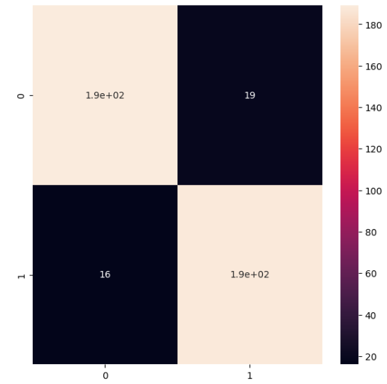
Figure 1 : Insert Suitable figure with suitable caption

Source Code:

C++
/*
Blink: Turns on an LED on for one second,
then off for one second, repeatedly. [cite: 18, 19]
*/

void setup() {
// initialize digital pin 2 as an output. [cite: 21, 22]
pinMode(2, OUTPUT);
}

void loop() {
digitalWrite(2, HIGH); // turn the LED on (5 volts) [cite: 25, 31]
delay(1000); // wait for a second
digitalWrite(2, LOW); // turn the LED off (0 volts) [cite: 26, 31]
delay(1000); // wait for a second [cite: 26]
}

Code Analysis:
- pinMode(2, OUTPUT): Configures the specified pin to act as an output so it can provide power to the LED.
- digitalWrite(2, HIGH): Sends 5 volts to the pin, completing the circuit to turn the LED on.
- delay(1000): Pauses the program execution for 1000 milliseconds (1 second).

Result and Discussion:
Upon successful uploading of the code, the LED connected to digital pin 2 began to blink continuously. The timing matched the code's instructions, alternating between "HIGH" and "LOW" states every second.

Conclusion:
The experiment successfully demonstrated the basic principles of Arduino programming and hardware interfacing. By utilizing the digitalWrite and delay functions, we established control over an external hardware component.

